FAST API DOCUMENTATION
- Install python idle
- Download python extension in vscode
- Need to install node.js also(for front end part using react)
- Then type (python -m venv myenv[name as u want ]) to create virtual enviroment for python and install packages only inside it
- To activate vitual enviroment go to myenv->Scripts->copy path of activate.ps1 and paste it in the terminal(powershell)
- Then install fastapi and uvicorn by typing (pip install fastapi uvicorn)

- By deafult the backend server runs on loalhost:8000
- Then to activate the server(uvicorn) type (uvicorn main:app --reload)

Api calling code via Fastapi(python)

Video 7

- Pip install sqlalchemy psycopg2
Definations
- SQLAlchemy is a high-level Python SQL toolkit and ORM (Object Relational Mapper).
It allows us to work with databases using Python objects instead of writing raw SQL, though we can write SQL if we want.
- It supports many databases (PostgreSQL, MySQL, SQLite, etc.) and often uses psycopg2 internally when working with PostgreSQL.
- In short:
- SQLAlchemy = Database abstraction + ORM (less SQL, more Python)
- psycopg2 is a low-level PostgreSQL database adapter for Python.
It lets Python programs directly connect to a PostgreSQL database and run raw SQL queries.
- we write SQL ourself (SELECT, INSERT, UPDATE, etc.), and psycopg2 just executes it and returns results.
- In short:
- psycopg2 = Python ↔ PostgreSQL connector (raw SQL)
Video 8 (FastAPI-Database Config)
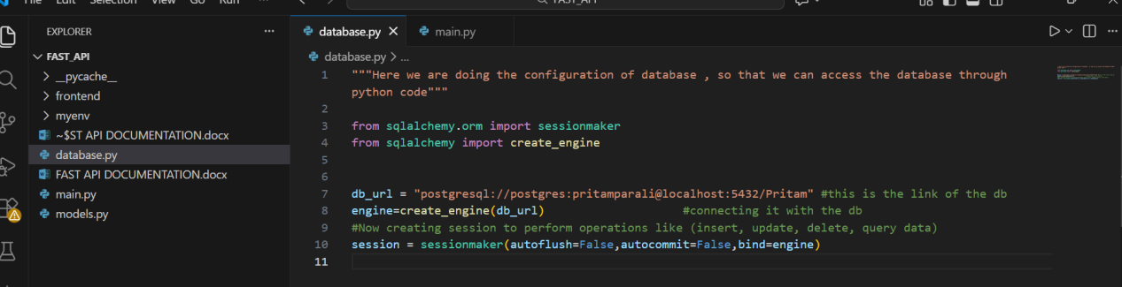
Here we will connect the database after configurating it in a separate file named database.py and here engine is used to connect the db and session is used to create session like insert update delete .
Now after that we have to import this object named session at main.py where we will use it and

We also have to create separate Product class for sqlalchemy/for the database,because we cant use the pydantic class at models.py
We can also specify the column types like int , varchar there and also we can specify primary key in that separate Product class that we have created for sqlalchemy/database

Video 9 (SQLAlchemy Model Creation)
Pydantic defination :- Pydantic in FastAPI is used for data validation, parsing, serialization, and automatic API documentation.
Here we will create a separate file for model creation for database
Like this
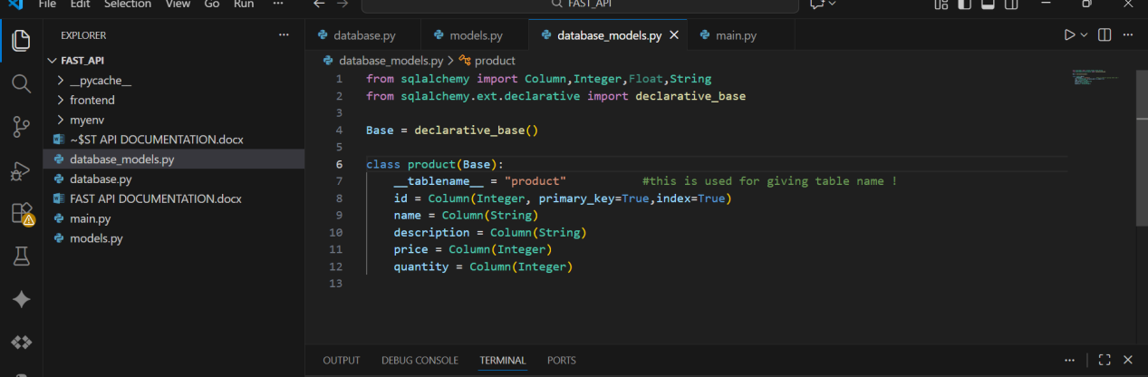
Then we will import this in main.py and there we will also run a line of code to create the table automatically in the database
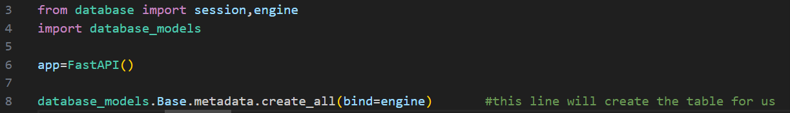

Video 10 (Initializing data)
Now we will insert the data in the database
We will insert the data now through this code in main.py::--
Here at first we will pass the objects of pydantic class into the sql alchemy class named product.
Then it will automatically add the data’s in the database .
We have also created a count condition where it will scan if the database is empty or not .if it is empty then the then only it will add the data’s in the database.(we have added this condition because there is a proomary key in the table and that’s why not duplicate value will be store in the table)

def init_db():
db=session()
count = db.query(database_models.product).count()
if count==0:
for product in products:
db.add(database_models.product(**product.model_dump()))
db.commit()

init_db()

Video 11
(Dependency Injection and Fetch from DB)
Here we have to create a function and inside that we will create a session object named (‘db’)so we don’t have create it in every functions/operations later
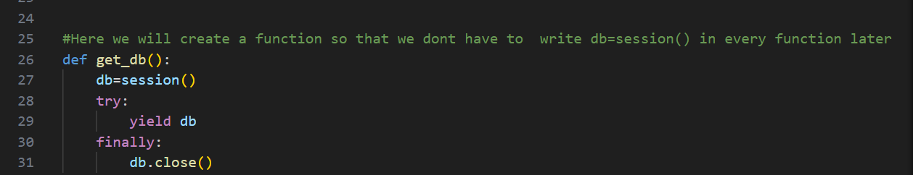

After this we will use this in one of our function
for that we have to first import
from sqlalchemy.orm import Session.After this we also have to import from fastapi import FastAPI,Depends
After that we will use it in fetching details from database

@app.get('/product')
def get_all_products(db:Session = Depends(get_db)):
db_products = db.query(database_models.product).all()
return db_products

Here , explanation of
db: Session = Depends(get_db)
This is dependency injection
What happens internally:
- FastAPI calls get_db()
- Gets the db session
- Passes it into this function
- After request → closes DB automatically
We don’t manually open/close DB here
FastAPI handles it for us
after this it will fetch all the details from backend .
After this we will also add this connection in fetch by id function also
#Now fetching the details by id
@app.get('/product/{id}')
def fetch_by_id(id: int , db:Session = Depends(get_db) ):
db_product = db.query(database_models.product).filter(database_models.product.id == id).first()
if db_product:
return db_product
return "product not found"
Explaination of the code ::
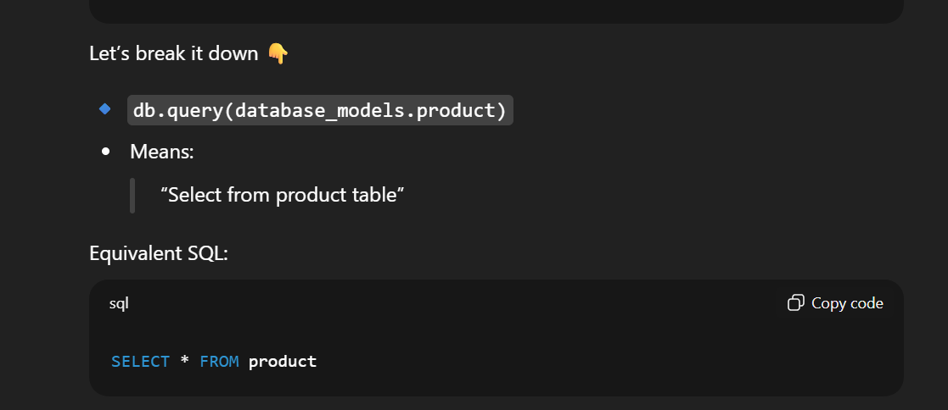
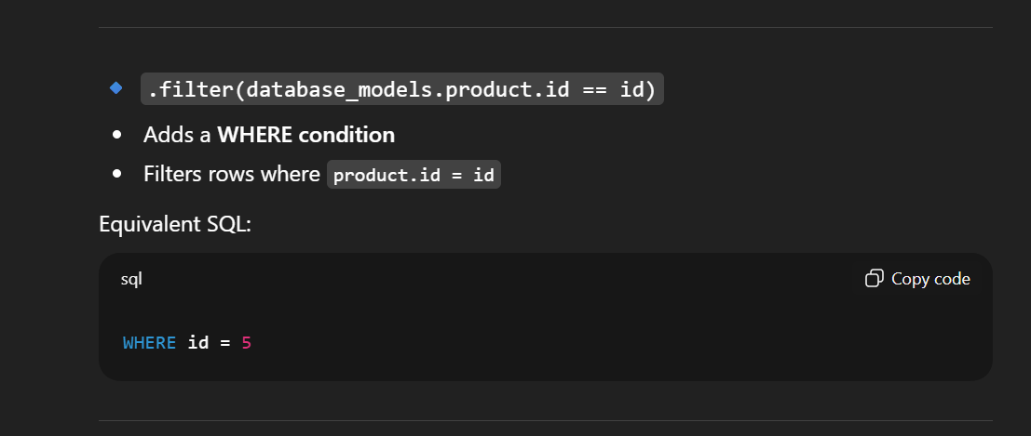
And .first() is like “Execute the query and give me ONE row”

